_______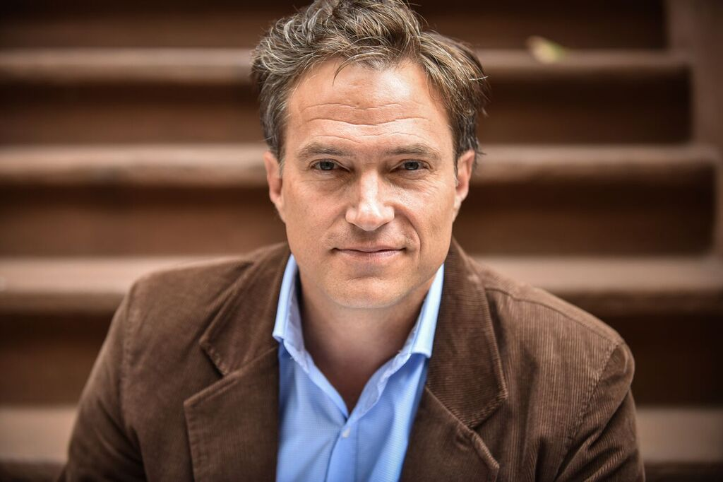
Douglas Everett Davis
SAG/AFTRA
Direct: 917.402.0228
douglaseverettdavis@gmail.com

TV
The Deuce Co-Star Alex Hall
Mrs. Fletcher (HBO 2019) Co-Star Carrie Brownstein
Constance Co-Star Jesse Peretz
Mostly 4 Millenials Co-Star Derrick Beckles
Odd Mom Out Co-Star Mike LaHaie
Younger (TVLand) Co-Star Andrew Fleming
Blood Feuds (AHC) Lead Andre de Brito

FILM
Beach Rats (Sundance best director 2017)) Supporting Eliza Hittman
Journey to the Last Christmas Dance Lead Nic Inglese
Who Knows Supporting Liat Shukrun
The Snack Bar Lead Francois Poisson
Somewhere in Love Supporting Amy Tong

THEATER
A Time to Kill Jake Brigance Francine Reynolds
The Wake (John Patrick Shanley) Guy Frank Licato
A Criminal Report Daniel Karen Carpenter
Wounded Warrior Capt. Phil Smith Christine Cirker
He Made The Trains Run on Time Samuel Adrian Wattenmaker
Women Are Crazy Men Are Assholes Reynold Cherry Lane Theatre
The Hard End Franklin Susan Batson

STAGED READINGS & STANDUP COMEDY
Steel Birds Admiral Wentworth Michele O’Brian
Madhouse Ensemble Roy Szuper
Sleepover Stories Alpha/Henry Courtney Harge
Standup Comic Standup NY
Standup Comic Gotham Comedy Club

TRAINING & SPECIAL SKILLS
Deborah Headwall Upright Citizens Brigade Susan Batson Studio
Weapon Handing for Actors – Westside Pistol Range Magaly Colimon
California State University Chico; Fordham University Michael Andrews Accent Coach

Comedy; improvisation. Accents, British, Southern. Firearms; basic singing. Valid NY Drivers license. Valid Passport.

